ASSIGNMENT-5
A.GOUTHAMI
H.NO:2303A53040
B-46

To develop and perform unit testing of smart contracts using
the Truffle framework
Objective
To implement a Personal Portfolio Smart Contract that stores and retrieves user profile data and verify its functionality using unit testing.
Requirements
- Node.js
- Truffle
- Ganache
- Visual Studio Code
Procedure
- Install required software.
- Create a new Truffle project.
- Write the Solidity smart contract (PersonalPortfolio.sol).
- Configure Ganache network.
- Compile the contract using truffle compile.
- Deploy using truffle migrate.
- Write unit test file in test folder.
- Run truffle test to verify functionality.
Result
The smart contract was successfully deployed and unit tested using the Truffle framework.

CODE:
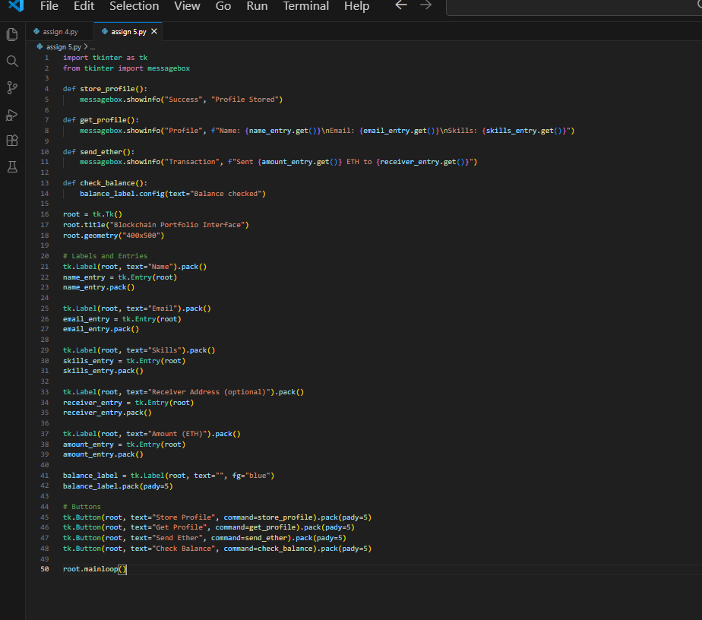

Output:
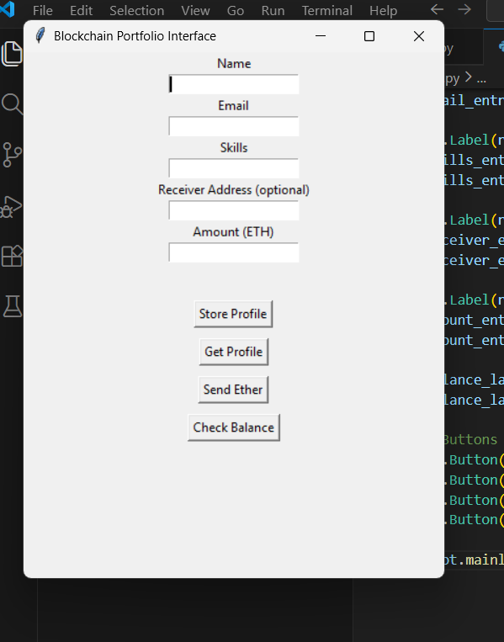
Conclusion
The Blockchain Portfolio application was successfully developed and connected to the local blockchain. All functions worked correctly, confirming proper smart contract and GUI integration.

